# Assignment –7

**Summarizing Data with Aggregate Functions.**

1. Write a query that counts all orders for October 3.

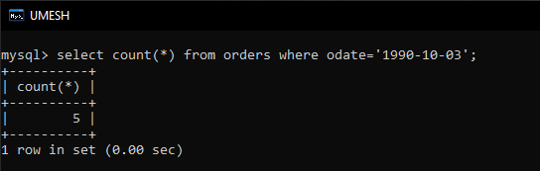

1. Write a query that counts the number of different non-NULL city values in the Customers table.

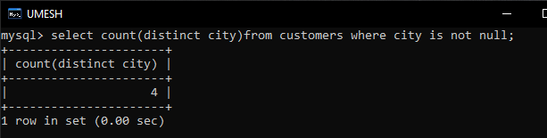

1. Write a query that selects each customer’s smallest order.

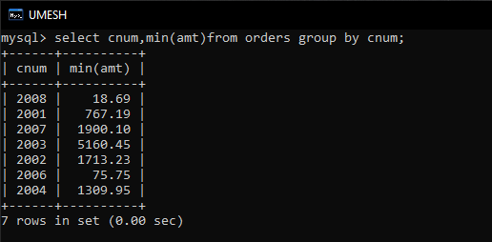

1. Write a query that selects the first customer, in alphabetical order, whose name begins with G.

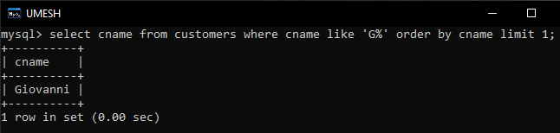

1. Write a query that selects the highest rating in each city.

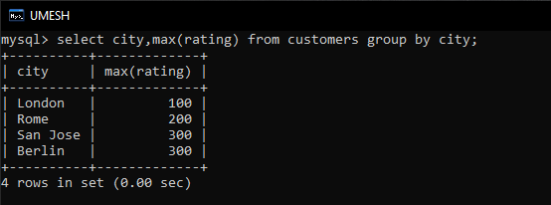

1. Write a query that counts the number of salespeople registering orders for each day. (If a salesperson has more than one order on a given day, he or she should be counted only once.).

